

Lab 3

Data Structure



September 11, 2025

Talha Abdullah Bangyal

SU92-BAIFM-F25-002

**Task 1**

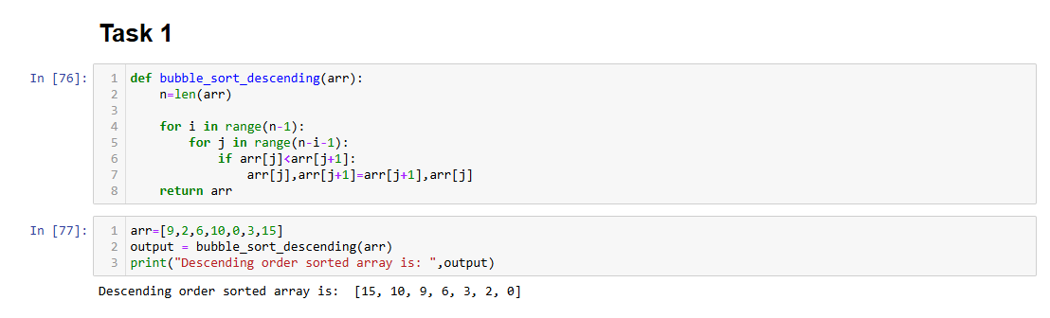

**Task 2**

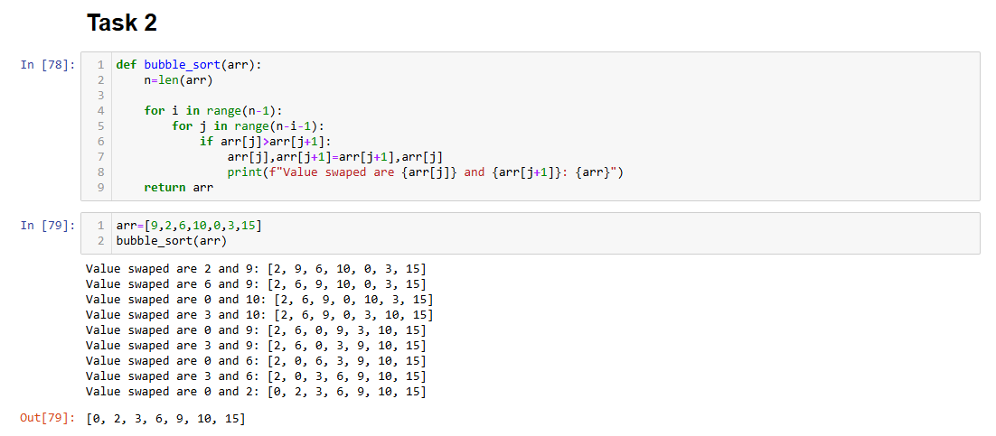

**Task 3**

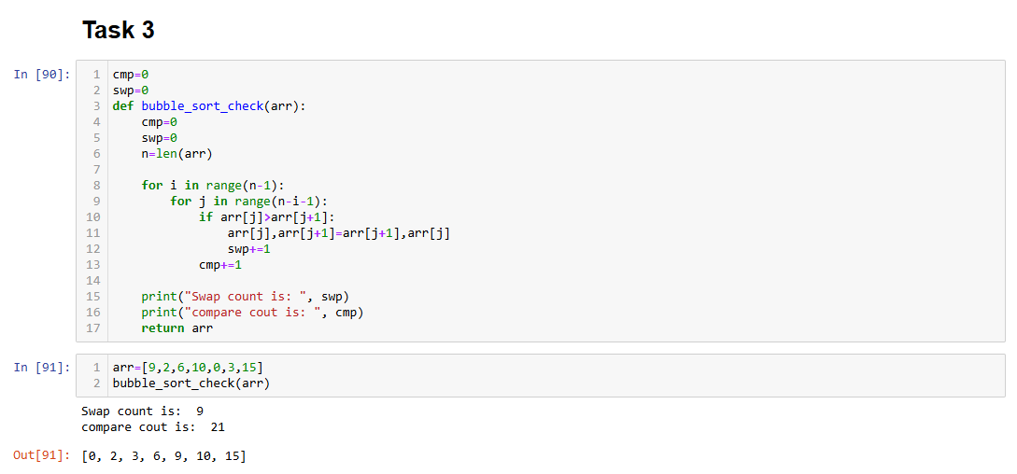

**Task 4**

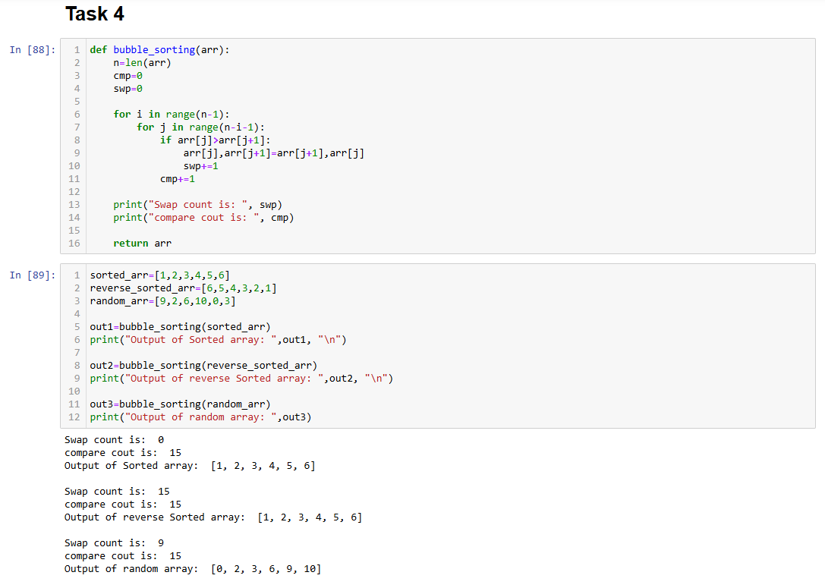

**Task 5**

